Minutes of the Committee Meeting 5th September 2016

Present:
Andy Reid Secretary
Chris Green Treasurer
Dave Debnam Vice President
Paul Davies Men’s Captain
Lorraine Webb Ladies Captain
Andy Ward
Miriam Linforth
Helen Morris

1 Chairman’s Comments
Reports that there were 26 new members in the beginners group.
The Alf Brown race was run in August.

2 Apologies
Apologies were received from Nathan Scott, Thom Darby

3 Previous Minutes
The minutes for August were accepted apart from correcting the Apologies as Ashley did not give apology for non attendance.

4 Matters Arising
There were no matters arising.

5 Secretary Report
Correspondence received:

Sports Tours International tours advert.
RAF Henlow 10ml race is on Weds 5th October
Wi C Bursary Coaching Workshops winter program.
SEAA AGM date on the 4th September
Alan Barry has been confirmed as 1st claim runner for Stopsley Striders
2017 Tokyo Marathon date
The RB Hull Marathon 2017 date
UKA Movement skills workshops.
Date for the Three Counties XC pre season meeting on 5th September
Advert for the Gloucester Marathon & 50Km run on 5.2.17

6 Treasurer’s Report
CG reports
Cash held £6724
Bank account £6724.71p
Charity money £1575.35p

Running Report
Running Report by Paul Davies & Lorraine Webb for August 2016
August is traditionally a quiet month, but not this year! This month has seen many Striders running parkruns on Saturday mornings, with some venturing as far as America! August has also seen Striders race trains, run 10K's, race triathlons, take on 86 mile challenges as well as marathons.
Many of us have also enjoyed the Rio Olympics and seen some truly wonderful achievements from the likes of our cyclists, our gymnasts, Mo doing this thing as well as the Ladies Hockey team. There's just too many great performances from Team GB to mention them all.
I am also really pleased to see that we have had upwards of 25 new members join us having graduated from the Beginners Course. I hope you all enjoyed the Beginners Speedwork that we put on for you and that you continue to enjoy your running experience as a Stopsley Strider. I would also like to personally thank those coaches who helped plan and deliver these sessions, as well as the many Striders who helped out and also took part. Without you this wouldn't have been possible.
Weekend of 5th, 6th & 7th August

On Friday night Amanda Rankin ran the Ipswich Twilight 10K in a time of 66:15.

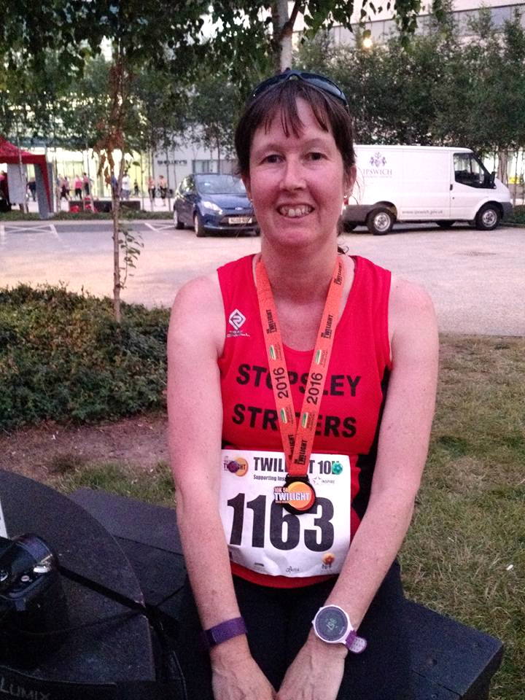

29 Striders ran the Luton parkrun on Saturday morning with Chris Green the first Strider home in 19:43. parkrun PB's were earnt by Lee Bearley (22:30), Christina Green (23:14 and 1st Lady), Carly Eaves (26:01), Kat Tuloo (29:47), Amrik Singh (31:49), Jo-Anne Cummins (32:35), Rachel Burns (35:44), Tommy Murphy (36:11) & Claire Bates (42:10).

Striders were being adventurous in the first week in August with many undertaking a bit of parkrun tourism on the Saturday. Amanda Rankin, fresh from her 10K the night before ran the Ipswich parkrun in 36:10, David Brown & Penny Kilbey who ran the St Albans parkrun in 28:33 and 36:55 respectively, Ellie Ballinger who ran the Telford parkrun in 26:44, Kelvin Chadwick (26:05), Nikki Cox (29:17) and Mark Layzell (32:04) who all ran the Fulham parkrun, Philip Davies (22:21) and Brian Davies (25:56) ran the Rushmere parkrun and Karen Bull ran a parkrun PB time of 36:09 at the Lytham Hall parkrun .

Also on Saturday Andy and Judy Reid both ran the York 10K with Andy finishing in 43:56 and Judy in 60:22.

On the Sunday, Gez Fallon ran the Riverside Runners 10K in St Neots, Cambs which is described as a summer cross country. Good to see you preparing yourself early for the impending cross country season Gez! Gez completed the race in 41.25.

Weekend of 13th & 14th August

23 Striders ran the Luton parkrun on Saturday morning with John Chapman the first Strider home in 20:07. Lee Bearley earned himself a parkrun PB when he finished in 21:58 as well as Iain Mose (26:50), Abigail Bruce (32:06), Jacky Richardson (34:06), Tommy Murphy (35:58), Pauline Moran (38:29) & Charlotte Williams (43:16).

Graham Busch ran the Bedford parkrun in 23:26, Maria Petts completed the Linford Wood parkrun in 31:28 and Mark Layzell continued his London parkrun tour by running the Peckham Rye parkrun in 31:45.

On Sunday, 3 Striders ran the Bearbrook 10K down in Aylesbury. First Strider home and earning himself a PB in the process was Ben Bodsworth who knocked 1 minute and 19 seconds off his previous PB when he crossed the line in 41.57. Next across the line was Dan Mann who also finished with a PB of 46:00. Dan was closely followed by Thom Darby who finished in 46.14.



Sunday also saw Striders Chairman, Nathan Scott take part in the London Brik Sprint Triathlon in Stewartby. After the swim stage Nathan came out of T1 in 1st place overall. Unfortunately during the bike he lost two places but on the run he managed to overtake a competitor to finish 2nd overall in a time of 1:02:34.
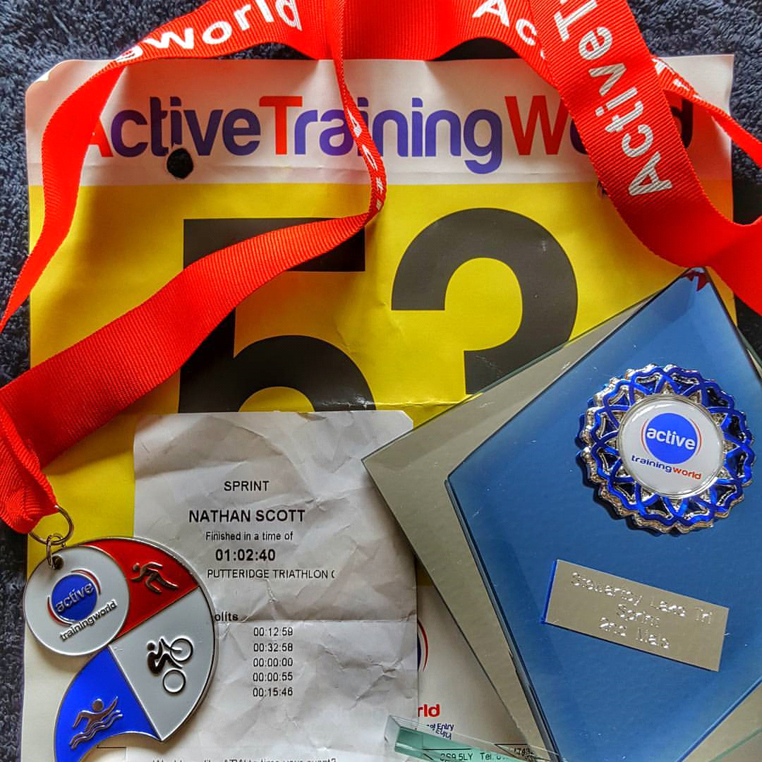
Andy Smith continued his marathon crusade when he ran The Punk Run. Andy finished the marathon in 4:19:03 and I think we can all agree the medal was definitely worth the 26.2 miles!

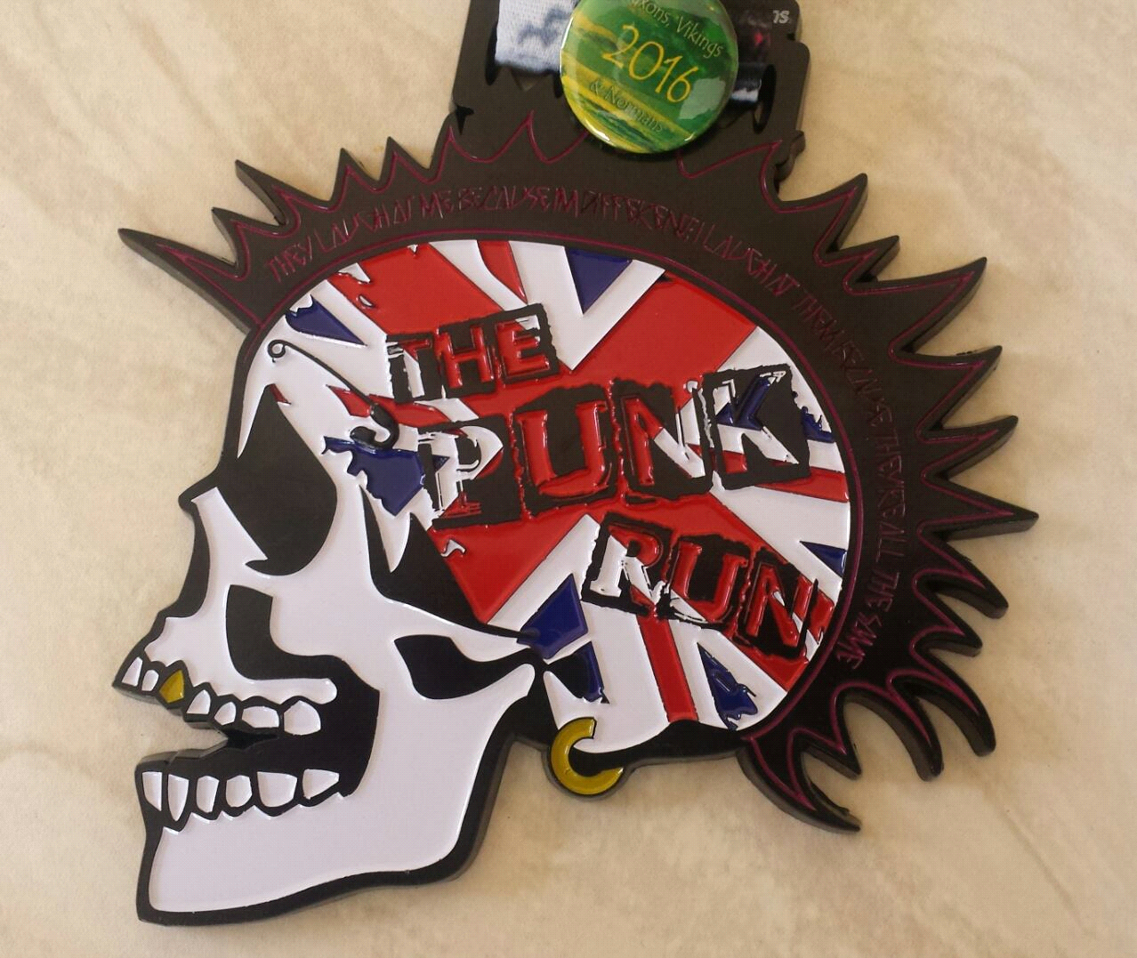

Thursday 18th August
Thursday saw the annual running of the Alf Brown Memorial. This 2 mile race is run every year in memory of a former Strider, Alf Brown. An amazing 48 Striders took part this year including many of our new members who graduated from the Beginners Course. In fact, the winner was one of our newest members, Amrik Singh! Well done Amrik and well done to everyone who took part.
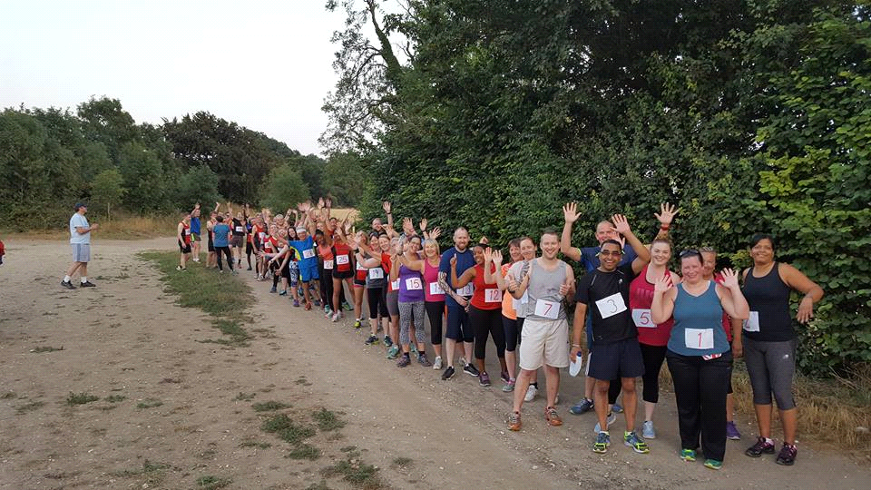

Weekend of 20th & 21st August
20 Striders ran the Luton parkrun on Saturday morning with John Chapman once again the first Strider home in 19:57. parkrun PB's were earned by Tommy Murphy (35:51), Richard Eaves (37:39), Lu Philpott (38:44) & Claire Bates (41:50).
Our parkrun tourists this week were Ellie Ballinger and Mark Layzell who completed the Greenwich parkrun in 28:37 and 40:49 respectively, Mark Sains who ran the Guildford parkrun in 19:56, Amanda Rankin completed the Folkestone parkrun in 35:30, Kate Neale who undertook the Fell Foot, Newby Bridge parkrun in 53:48 and finally Paul Keech (24:31) and Graham Busch (27:29) who ran the Rushmere parkrun.
On Saturday Pete Croall took part in Race the Train. For those unfamiliar with this race, it's an annual cross country race that takes place in Tywyn, Mid Wales and as you may have already guessed, the challenge is to beat a steam train over a distance of 14 miles. Although falling twice and battling strong winds, Pete managed to keep his unbeaten record up and beat the train in a time of 1:42:38.
Bank Holiday Weekend of 27th, 28th & 29th August
16 Striders ran the Luton parkrun on Saturday morning with John Chapman the first Strider home in 20:16. Gaining parkrun PB's were Sonia Blackett (27:39), Rachel Burns (34:14), Janine Blackett (35:23), Tommy Murphy (35:32) & Charlotte Williams (42:08)
Striders had quite a few parkrun tourists again this week with Philip Davies (20:57), Stewart Read (24:23), Liz Davies (27:03) and Mark Layzell (37:43) all running the Richmond parkrun, Pete Croall ran the Reading parkrun in 19:04, Mark Sains ran the Guildford parkrun in 18:15, Christina Green earned herself another parkrun PB when she ran the Exeter Riverside parkrun in 22:07, Ellie Ballinger completed the Dartford parkrun in 27:08 and Graham Busch ran the Rushmere parkrun in 25:37.
By far our farthest parkrun tourist this week was Zena Ellis who ran the Clermont Waterfront in Florida in a time of 29:23.
Also on Saturday Carly Eaves ran the Tribe 10K which she completed in 1:04:38. Carly described the race as "one big uphill climb with a few death traps thrown in!" I presume you've already signed up for next year's race then Carly?!


Over the weekend Rob Barnes and Annelies Gerber took on the 86 mile Ridgeway Challenge. Rob finished in 6th place overall in a time of 17hrs 23 mins and Annelies finished in 48th with a time of 23 hours 53 minutes. Well done both, awesome achievements!
On the Sunday, Andy Smith ran the Planes, Trains & Automobiles Reverse Marathon in Milton Keynes. Andy completed this marathon in a time of 3:55:32.
On Bank Holiday Monday, Ellie Ballinger ran the Canterbury Half Marathon. Although Ellie was ill during the race this did not deter her and she dug deep to finish in 2:26:23. Well done Ellie, a great achievement considering the circumstances.
Tuesday 30th August
17 Striders took part with Dunstable Road Runners in a 5000m Time Trial held at Stockwood Athletics Track which saw over £250 raised for Help the Heroes. Striders took the top 3 positions in the mens race (Tom Hull 18:18, Karl Tull 18:26 & Pete Croall 18:29) as well as 1st and 3rd in the ladies race (Christine Lathwell 20:04 & Christina Green 22:04). It was also great to see Miriam Linforth back running whilst pushing Baby Lara in her buggy! Well done to all those who took part. Full results can be found on the Stopsley Striders Facebook page.
So that's August done and dusted but what will September bring? The nights are drawing in rapidly so it won't be long till we are back on the pavements of Luton. As it begins to get darker earlier, please remember to wear bright clothing when out running at night, for your own safety and above all else, continue to enjoy your running.

Beginners Course Survey

Paul and Lorraine report that they have not seen it.
Nathan has Emailed it out to new group.

Strider of the Month Trophies

Group decision to not award it this month as we could not see a suitable candidate in the month.

Chairman

Nathan has announced his intention to resign from the position, though will stay on until the AGM.

AGM

The date has been set as the 17th November 2016
Voting forms will be needed by the middle of October at meeting evenings.
Talk to Stuart re booking the venue.
Book the Crawley Green Hall.

7 Suggestions

Rachel Burns: Have we an updated flyer for the club promotion? We will look at it in the new year. Zena will look at the old flyer supplied by Helen.
Martin Smith: would like a runner to pace him.
Tony Riley: Requested a club organised trip to an Athletics event. No

A.O.B.

Dave Thompson asked for another Striders Quiz night.
Nathan has ordered the Strider of the Month trophy for Christina for July.
Striders race now has 49 entrants so far.
The two P.R. people – What do they do? Not known.
The New Members Pack needs modifying to include updated details of how to get a vest. The New Member Form is on the Website..
Speedwork: We need to agree a format for Thursdays.
The Beginners intermediate session and a more advanced session. Rename to Group 1 and Group 2. Faster runners to be in Group 1.
Social Evening to be 29th September.
The XC dates are: 23.10.16. Wellingborough, 20.11.16. Wooton, 27.11. Wing,
18.11.16. Standalone, 22.01.16. Sharnbrook

Miriam will create a Runner Profile for next month.

The meeting ended at 9.10pm

Next Meeting to be held in the Barrels on 3rd October 2016

